COMPLETE LOOK, SAY, ACT, COVER, WRITE, CHECK with ALL SPELLINGS. |  |  |  | Name:__ Date 22/2/21  Vocabulary in Action – Year One  If you complete this booklet and would like to do more, here are a couple of extension activities you can do:  Rainbow write  First, write each word in pencil, then trace over each word three times, each time you trace you must use a different colour crayon and say the sounds.  Air Write!  Write your spelling words in the air using your finger. Ask someone to read your words as you write them OR have them air write and you read them.  Opposites by adding Prefix un  happy unhappy  helpful unhelpful  lock unlock  tie untie  fold unfold  pack unpack  Can you think of any more words that you can put the prefix ‘un’ at the beginning and create opposite words?  Write them below.
happy
unhappy
helpful
unhelpful
lock
unlock
tie
untie
fold
unfold
pack
unpack

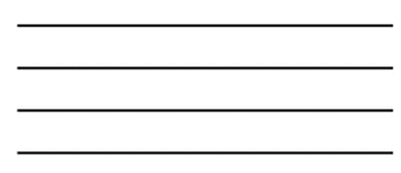
- Choose three words.
Then draw a picture for each word.

2. Now choose three different words and put them into a sentence.

